BRAINLENS – A MULTIMODEL ARTIFICIAL INTELLIGENCE SYSTEM FOR STROKE DETECTION AND RISK PREDICTION

FIELD OF THE INVENTION
The present invention is related to the artificial intelligence technology used in the medical and healthcare sector. Specifically, it pertains to a multimodal diagnostic system that utilises deep learning and sequential learning methods for the automatic detection of strokes and prediction of future risks using medical imaging and clinical data.

BACKGROUND OF THE INVENTION
Stroke is a serious neurological condition and a leading cause of death and disability worldwide. Early and accurate diagnosis is essential for successful treatment; however, the conventional stroke diagnosis is highly dependent on the manual analysis of CT/MRI images and clinical assessment by expert neurologists. This is a time-consuming, subjective, and expert-dependent process, especially in rural and developing regions.
Conventional computer-assisted diagnostic systems are often designed to analyse only one type of data, whether it is medical images or structured clinical data. Image-based systems are prone to neglecting critical risk factors present in the patient’s medical history, while data-based systems fail to identify real-time abnormalities in the brain. Furthermore, conventional systems are often non-interpretable, and clinicians are unable to validate and rely on AI-driven diagnostic outcomes.
Thus, there is a pressing need for a smart and comprehensive diagnostic system capable of effectively analysing and combining multiple sources of data for accurate, interpretable, and real-time stroke detection and risk prediction.

OBJECTS OF THE INVENTION
The objectives of the present invention include:
• Developing an automated system for stroke detection from CT/MRI images of the brain.
• Developing a system for predicting the risk of future strokes based on patient clinical and lifestyle inputs.
• Developing a system that combines CNN and BiLSTM models for multimodel learning.
• Developing a system that improves the accuracy of diagnosis by fusing multimodal data.
• Developing a system that provides explainable AI results for clinical interpretation.
• Developing a system that enables early intervention and preventive care.

SUMMARY OF THE INVENTION
The invention presents a multimodel artificial intelligence system that can detect strokes and predict the risk of future strokes by analysing both medical imaging data and clinical information of patients. A Convolutional Neural Network (CNN) is used to analyse CT/MRI images of the brain to detect abnormalities associated with strokes, while a Bidirectional Long Short-Term Memory (BiLSTM) network is used to analyse sequential and clinical data to predict patterns of strokes.
The results of the CNN and BiLSTM networks are combined to produce a single diagnostic result and risk classification. The system provides visual explanations and risk classification to help clinicians make informed decisions. The invention combines image analysis and clinical prediction in a single system, thus improving the accuracy, speed, and interpretability of the diagnostic results.

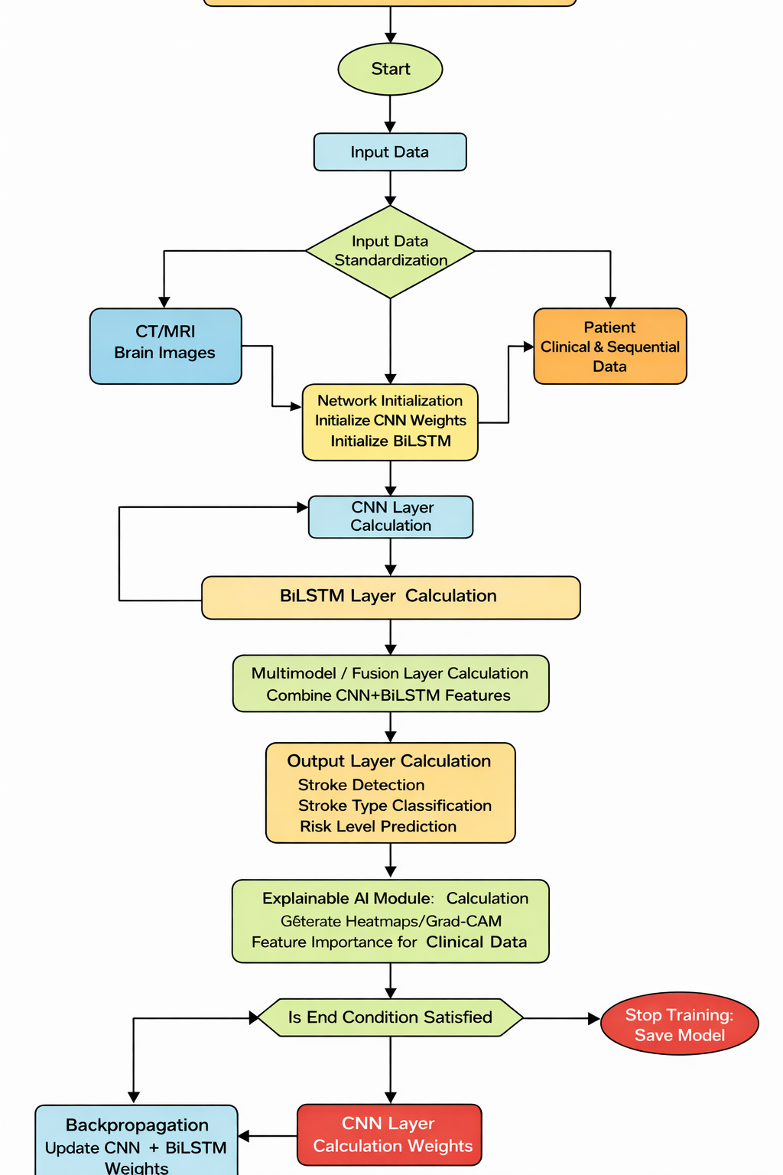
BRIEF DESCRIPTION OF THE DRAWING

Process Flow Diagram

The process flow diagram describes the steps involved in the system. The process flow diagram starts with user authentication, followed by image upload and clinical data input. The diagram continues with image preprocessing, feature extraction using a CNN, clinical analysis using BiLSTM, multimodel fusion, and final stroke detection and risk prediction results. The diagram highlights the functional interaction, not the internal technical code.

DETAILED DESCRIPTION OF THE INVENTION
The system consists of a medical interface used by medical professionals to upload brain CT/MRI scans and enter the patient's clinical parameters, such as age, blood pressure, glucose level, cholesterol, BMI, and medical history. The uploaded image is first processed by an image preprocessing module.
The pre-processed image is then fed into a CNN model that identifies spatial features and lesions related to strokes. Simultaneously, the clinical and sequential patient data are analysed using a BiLSTM model that identifies temporal patterns and risk trends from the patient’s historical and current data.
The results from both models are then combined using a multimodel fusion engine that generates a final classification result for stroke presence, stroke type (ischemic or hemorrhagic), and risk level (low, medium, high).
An explainable AI component is used to generate visual heatmaps on brain images and feature importance scores on clinical variables. The results are then presented through a user-friendly dashboard and stored in a secure database for future access and tracking.

CLAIMS

Claim 1
A multimodel artificial intelligence system for stroke detection and risk prediction, comprising:
A CNN-based image analysis module configured to detect stroke lesions from CT/MRI scans;
A BiLSTM-based clinical analysis module configured to analyse patient health and temporal data; and
A fusion engine configured to combine outputs from both models into a unified diagnostic result.

Claim 2
The system of claim 1, wherein the CNN model identifies spatial features of brain images to classify stroke type.

Claim 3
The system of claim 1, wherein the BiLSTM model analyses sequential clinical data to predict future stroke risk.

Claim 4
The system of claim 1, wherein the fusion engine combines imaging and clinical predictions for improved accuracy.

Claim 5
The system of claim 1, wherein explainable AI methods produce visual heatmaps on medical images.

Claim 6
The system of claim 1, wherein risk levels are classified into low, medium, and high classes.

Claim 7
The system of claim 1, wherein the system supports real-time diagnostic output.

Claim 8
The system of claim 1, wherein patient data and prediction outcomes are secured.

Claim 9
The system of claim 1, wherein the system helps clinicians in early stroke intervention.

Claim 10
A computer-implemented method for stroke detection and risk prediction using image processing, clinical data analysis, multimodel fusion, and result visualisation.

ABSTRACT
The invention pertains to a multimodel artificial intelligence system for automated stroke detection and risk prediction from medical imaging and clinical data. A CNN model processes CT/MRI brain images to detect stroke abnormalities, and a BiLSTM model assesses patient health and temporal information to predict future stroke risk. The prediction results of both models are combined using a fusion engine to produce accurate, interpretable, and real-time diagnostic outputs. By combining image-based stroke detection and clinical risk prediction in a unified system, the invention enhances diagnostic efficiency, facilitates early intervention, and optimises preventive healthcare management.

